***On my honor, I pledge that I have not violated the provisions of the NJIT Student Honor Code***

STUDENT TEAM N**o** __2__

Name Signature

…Arsh Bhamla………… **ARSH BHAMLA~~___~~**_ …Pranay KC………….. _**_PRANAY RAJ KC_____** ..Shreedhar Rajendran. **__Shreedhar Rajendran—**

..Christopher Karkenny. __**Christopher Karkenny**_

Experiment performed on date _02/ 14 / 2025__

Report submitted on date _________

Returned for corrections on date _________ Grade ______

Returned after corrections on date _________ Grade ______

**Introduction**

In this lab, we will explore the applications of shift registers and see how they fit into digital electronics through hands-on experiments. First we will begin by putting together a 4-bit serial-in, parallel-out, shift register using two 7474 dual flip-flops to understand the data shifting process. Next we will extend our shift register to build a pseudo-random binary sequence generator, utilizing the IC 7486 to introduce the concept of randomness in circuits. Finally, we will design a serial adder to perform binary addition serially using two 74164 8-bit shift registers and a full adder. These experiments will provide practical insights into the functionality and significance of shift registers, pseudo-random sequence generators, and serial adders, demonstrating their importance in digital systems and serial computation.

**Procedure**

**3.1 4-bit Shift Register**

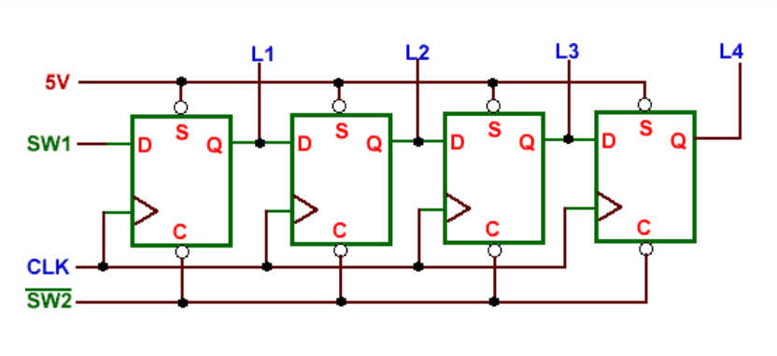

Fig 1. 4-bit Shift Register shown from [ECE 294 lab manual](https://ecelabs.njit.edu/ece294/lab3.php).

We constructed a 4-bit serial-in, parallel-out shift register using two 7474 dual flip-flops. We connected four LEDs to the flip-flop outputs to visualize the data shift, and used switches to control the input states. We cleared the register, then shifted data into the register by toggling the pulser, observing the LEDs light up as the data shifted. We repeated the procedure by changing the input states.

**3.2 Pseudo-random Sequence Generator**

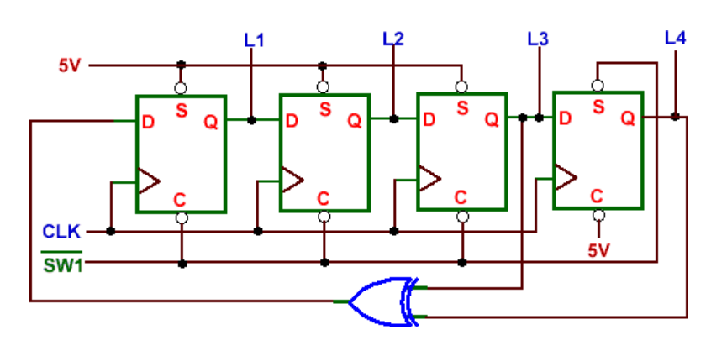

Fig 2. Pseudo-random Sequence Generator shown from [ECE 294 lab manual](https://ecelabs.njit.edu/ece294/lab3.php).

We integrated the IC 7486 exclusive-OR into the 4-bit shift register to create a pseudo-random binary sequence generator. We set the initial state of the shift register to 0001, then applied clock pulses while recording the output.

**3.3 Serial Adder**

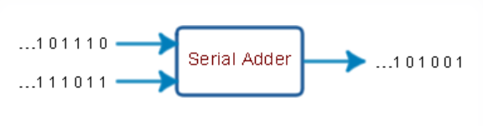

Fig 3. Serial Adder shown from [ECE 294 lab manual](https://ecelabs.njit.edu/ece294/lab3.php).

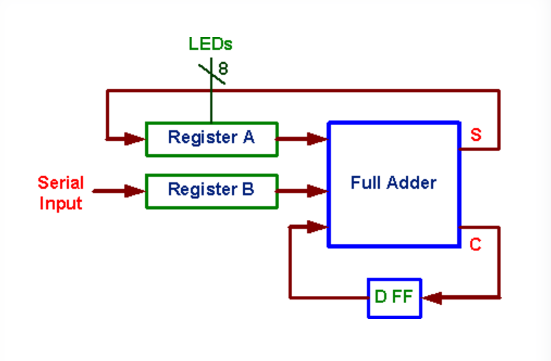

Fig 4. Block diagram of Serial Adder shown from [ECE 294 lab manual](https://ecelabs.njit.edu/ece294/lab3.php).

We designed a serial adder using two 74164 shift registers, a full adder, and a D flip-flop. The two binary numbers were serially added by shifting bits into the registers and processing them through the full adder and the carry output was stored in the D flip-flop and used as the input carry for subsequent additions. We cleared the registers and flip-flop, loaded the binary numbers, and performed serial addition over several clock cycles. The sum was recorded in register A.

**Data and Calculations**

**3.1 4-bit Shift Register**

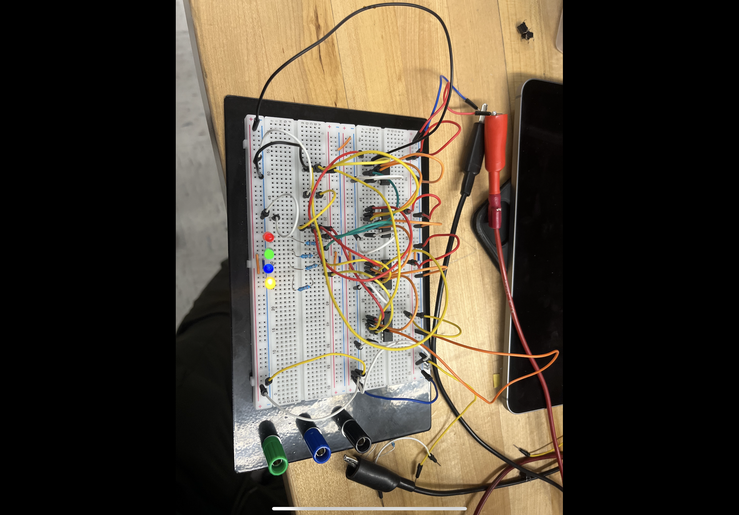

**3.2 Pseudo-random Sequence Generator**

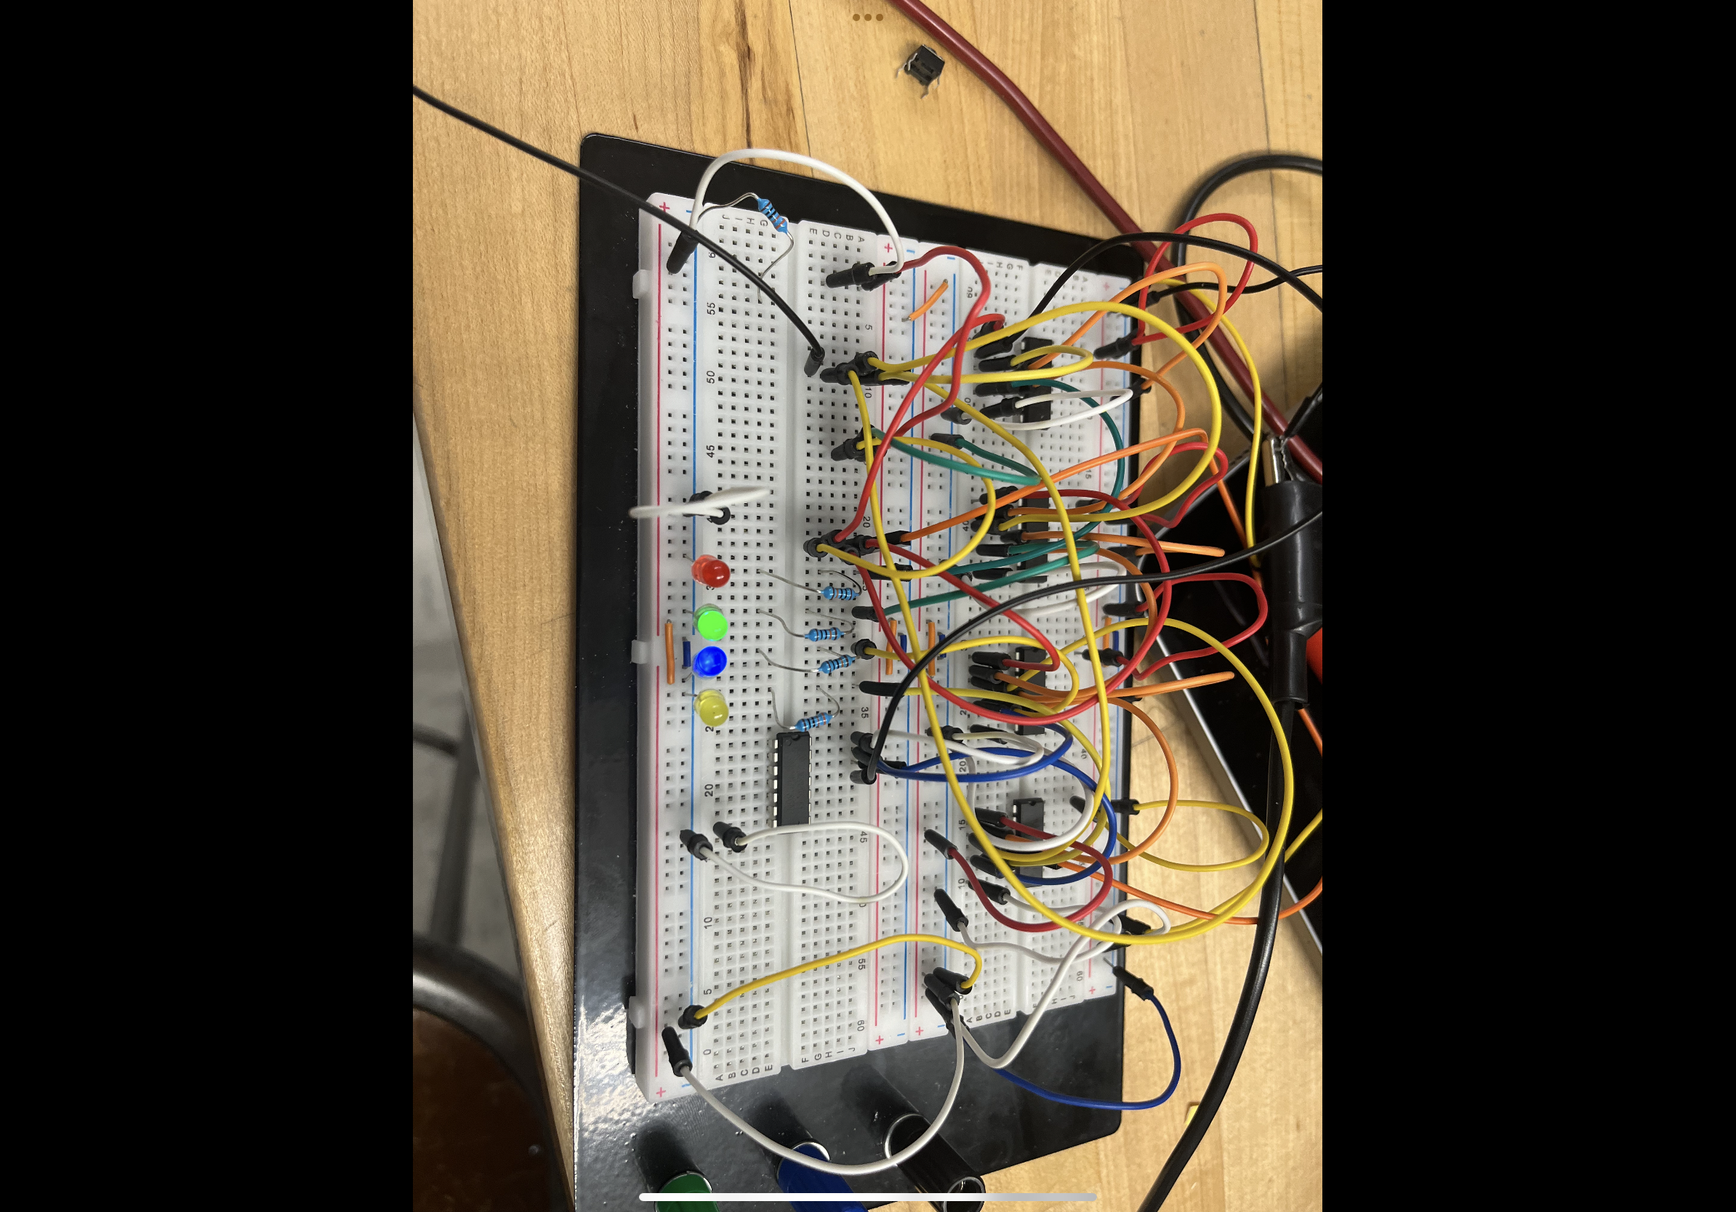

**3.3 Serial Adder**

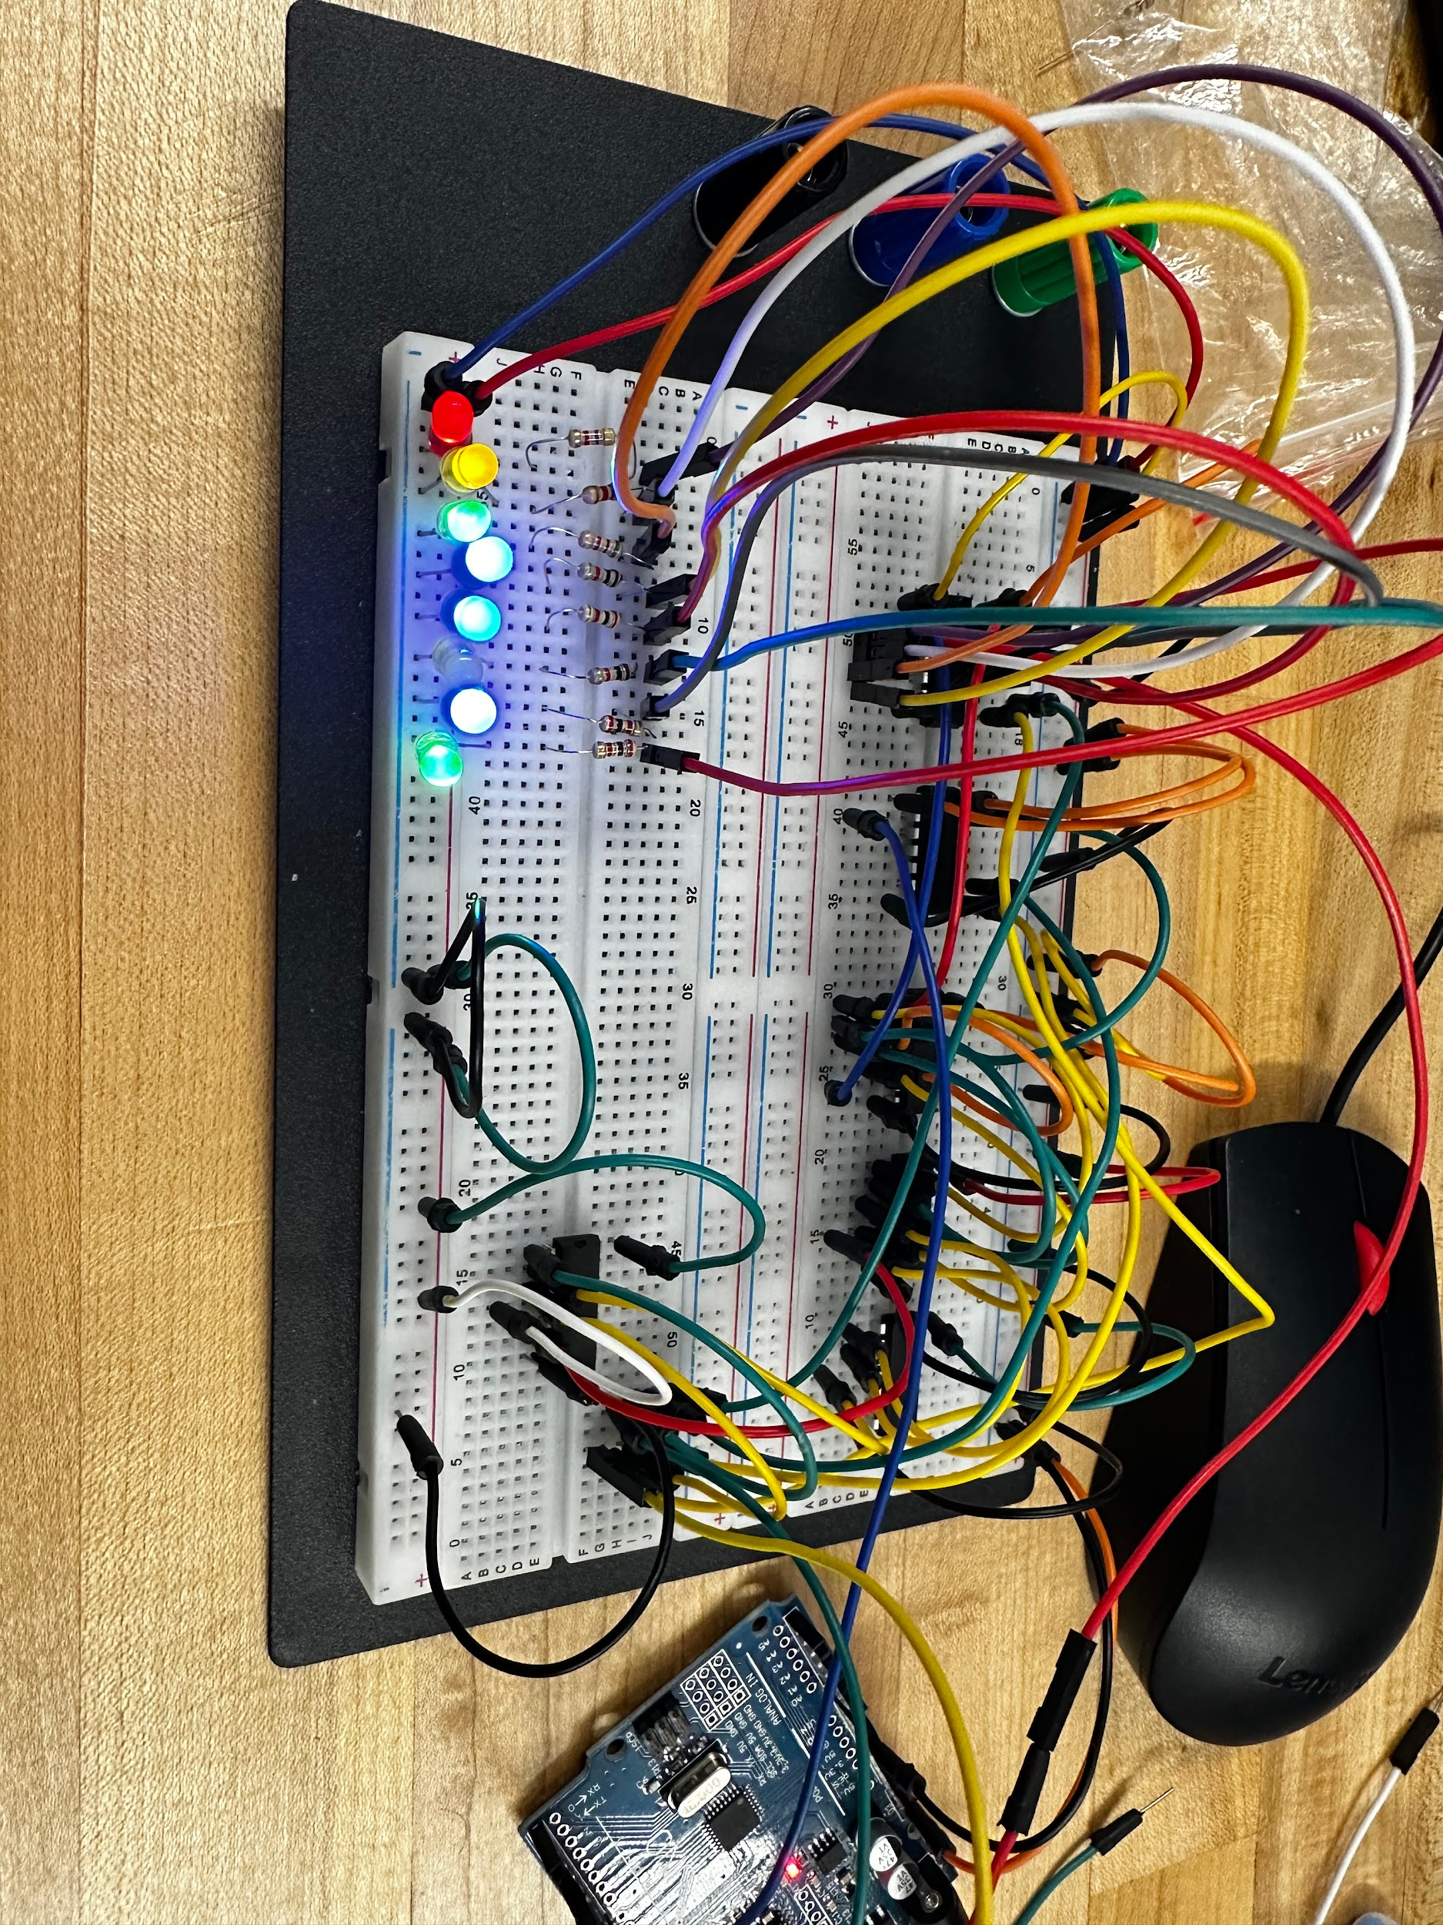

Circuit Demonstration

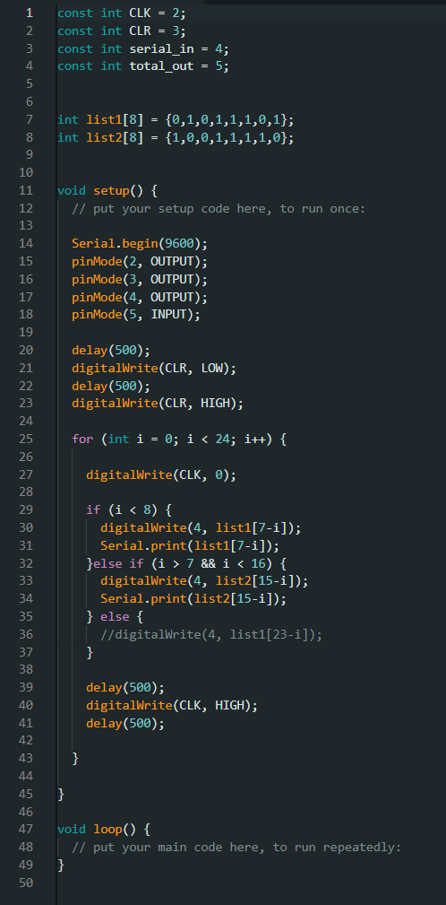

Fig. Code for 3.3 serial adder

**Discussion**

**3.1 4-bit Shift Register**

In this experiment, we built a 4-bit serial-in, parallel-out shift register using two 7474 dual flip-flops and observed how data shifts through LEDs. Our setup included connecting two outputs of each flip-flop to LEDs (L1-L4) through resistors. SW1 and SW2 controlled the inputs of the flip-flops and the clock input was connected to a pulser. First, we set SW2 to logic 1 which cleared all the flip-flops, meaning all outputs will be logic 0 and turned off all the LEDs. Then, we set SW1 to logic 1 ad SW2 to logic 0, and push the pulser button a few times causing a logic 1 to shift into the register, lighting up the LEDs one by one.This experiment was repeated with SW1 set to logic 0, which shifts a logic 0 into the register, turning off the LEDs in sequence. We observed the state of the LEDs when SW2 is at logic 1, how the LEDs behave as logic 1 is shifted in, and how they behave as logic 0 is shifted in.

**3.2 Pseudo-random Sequence Generator**

In our second experiment, we took the 4-bit serial-in, parallel-out shift register we built earlier and turned it into a pseudo-random sequence generator. The setup is shown in Fig. 2 where the generator produced a random output that repeated every 2^n-1 bits, when n was the number of flip-flops in the shift register. We used an IC 7486 for the XOR gate in the circuit. First, we set the initial state of the shift register to 0001 by setting SW1 to logic 1 and then we changed SW1 to logic 0 to release the control input. When applying the clock signal we watched and recorded the output in a table. Our main goal was to see if the output looked random and if the sequence repeated after 15 pulses, since we used a 4-bit shift register (n=4).

**3.3 Serial Adder**

In our third experiment, we built a serial adder to add binary numbers one bit at a time using a simple full adder- where the carry out from the full adder was sent into a D flip-flop and this flip-flop’s output was used as the carry input for the next set of significant bits, as shown in Fig .4. We used two 74164, 8 bit- serial-in, parallel-out out shift registers to store the binary numbers we wanted to add. The bits were added in pairs using the full adder, and the carry out from the full adder went into the D flip-flop, and the flip-flop’s output was used as the carry input for the next bits with the sum from the full adder going into register A as the contents of the register were shifted out. To perform the addition, we first shifted the 8-bit augend into register A and the 8-bit addend into register B by clearing registers A and B and the D-flip flop.We shifted the augend through the serial input, and for each of the eight clock cycles one bit was shafted into register B starting with the LSB. Since registers A and B were initially all zeros, the full adder’s output was 0 for both the sum and carry during these cycles. After eight clock cycles, register B held one operand and register A was all zeros. Once we shifted the addend through the serial input while the augend was shifted out of register B and into register A. After eight clock cycles, register A held the augend and register B held the addend.

Arduino code for the serial adder:

Instead of manually entering the input by changing the polarity of the wires, we decided to make a simple arduino code which enters the two inputs and shows their addition with shift registers.  
  
The code starts with declarations of different pins for the clock, clear, the input and the output. Then two arrays list1 and list2 are created to store the two numbers to be added. The 8-bit binary digits are stored such that each digit is an index of the array.

Onto the void setup(): We first setup the pins as input or output. Then throughout the code, we use a delay of 1s in total by using two delays of 500ms after each significant step, which is a frequency of 1Hz.

Then we start a for loop that runs 24 times representing the 24 clock cycles. First we set up the clock as high by outputting 0 (as it is a low-enabled pin). After that we start an if-statement which accepts the condition of i < 8. If the condition is met then it's gonna read the list1 from the back, and we print it as a measure to check if the code is working. Then the else if statement works if 7 < i < 16, to represent the clock cycle from 8 to 15, where it reads the second list and adds the two lists and displays it as a sequence of on and off LEDs.

Finally we set delays and set the clock as HIGH (clock turned off).

**Conclusions**

The conclusion of this lab wrapped up three key experiments that gave us an understanding of shift registers and their uses. In the first experiment, we built a 4-bit serial-in, parallel-out shift register using two 7474 dual flip-flops, showing how data shifts through LEDs. This helped us understand the concepts of shift registers and how they handle data serially. The second experiment turned the shift register into a pseudo-random binary sequence generator with an IC 7486 for the XOR function. We checked out the random output and its periodicity proving that the generator worked and produced a repeating sequence after 15 pulses. The final experiment had us building a serial adder using two 74164 8-bit shift registers and a full adder, showing how to add binary numbers serially. By following the step by step procedures, we saw the carry transfer and sum accumulation, confirming that the serial adder worked properly. Overall, the lab gave us hands-on experience with shift registers, pseudo-random sequence generators, and serial adders.